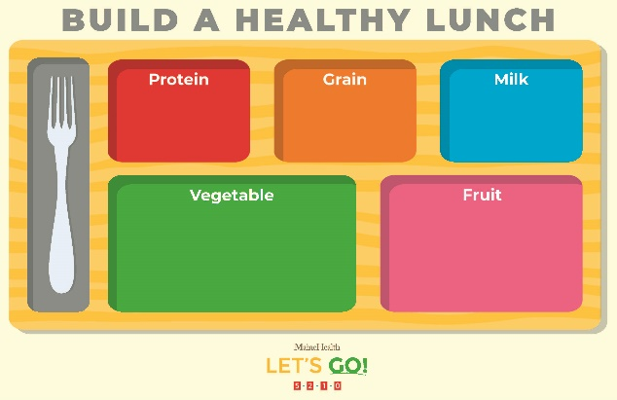

**At *insert School District or School Name***

***Insert website of school meals menu***

**Food Service Director Name  
207-207-5210  
email@address.com**